**Session-15 Assignment**

**Name:-** Aryan Dilipbhai Langhanoja

**Enroll No:-** 92200133030

**AIM**: To understand CE Amplifier.

**Apparatus:**

1. Function generator
2. Dc power supply
3. Switch
4. Transistor (BC547)
5. Capacitor
6. Resistors
7. Oscilloscope

**Task-1-** CE Amplifier with Voltage Divider Bias

**Sample Circuit diagram:**



**Multisim Circuit:**

**Frequency Response of an CE Amplifier:**

|  |  |  |  |  |  |
| --- | --- | --- | --- | --- | --- |
| **Sr. No.** | **Input Frequency**  **Hz** | **Input Voltage**  **(Vpin)** | **Output Voltage**  **(Vpop)** | **Gain (G)**  **(Vpop / Vpin)** | **Gain**  **dB**  **20 log G** |
| **1** | 1 Hz | 5 mV | 8.406 mV | 1.6812 | 4.512388 |
| **2** | 10 Hz | 5 mV | 45.545 mV | 9.109 | 19.18941 |
| **3** | 100 Hz | 5 mV | 418.809 mV | 83.7618 | 38.46092 |
| **4** | 1 K Hz | 5 mV | 1.310 V | 262 | 48.36603 |
| **5** | 10 K Hz | 5 mV | 1.426 V | 285.2 | 49.10299 |
| **6** | 100 K Hz | 5 mV | 1.347 V | 269.4 | 48.60795 |
| **7** | 1 M Hz | 5 mV | 1.307 V | 261.4 | 48.34611 |
| **8** | 10 M Hz | 5 mV | 1.069 V | 213.8 | 46.60015 |
| **9** | 100 M Hz | 5 mV | 290 mV | 58 | 35.26856 |
| **10** | 1 GHz | 5 mV | 18.134 mV | 3.6268 | 11.19047 |
| **11** | 10 G Hz | 5 mV | 1.871 mV | 0.3742 | 3.789806 |

**Frequency Response of An CE Amplifier using Excel:**

**Gain (dB) (Y axis) vs Frequeny (X axis)**

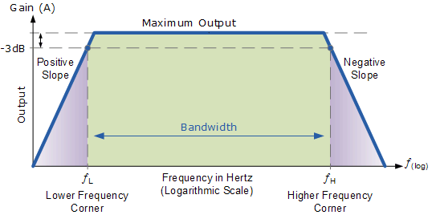

**Importance of Coupling Capacitor:**

* The role of coupling capacitors is to prevent the incoming AC signal from interfering with the bias voltage applied to the base of a transistor.

**Importance of Bypass Capacitor:**

* A bypass capacitor is added to an amplifier circuit in order to allow AC signals to bypass the emitter resistor.

**Conclusion:**

**____________________________________________________________________________________________________________________________________________________________**